**Notice of General Election and Sample Ballots**

**November 5, 2024**

**Office of the Oneida County Clerk**

**To the voters of Oneida County:**

Notice is hereby given of a general election to be held in the several wards in Oneida County, on November 5, 2024, at which the officers named below shall be chosen. The names of the candidates for each office to be voted for, whose nominations have been certified to or filed in this office, are listed under the title of the office and under the appropriate party or other designation, together with any referendum questions submitted to a vote, in the sample ballot below.

**INFORMATION TO VOTERS**

Upon entering the polling place and before being permitted to vote, a voter shall:

* state their name and address
* show an acceptable form of photo identification*
* sign the poll book**

**\*If a voter does not have acceptable photo identification, the voter may obtain a free photo ID for voting from the Division of Motor Vehicles.**

**\*\*If the voter is unable to sign the poll book due to disability, a poll worker may write the word “exempt.”**

If a voter is not registered to vote, they may register to vote at the polling place serving their residence if the voter provides proof of residence.

Where ballots are distributed to voters, the initials of two inspectors must appear on the ballot.

Upon being permitted to vote, the voter shall enter a voting booth or go to a machine and cast their ballot. The vote should not be cast in any manner other than specified here. Sample ballots or other materials to assist the voter in marking their ballot may be taken into the booth and copied. The sample ballot shall not be shown to anyone so as to reveal how the ballot is marked.

A voter who is a parent or guardian may be accompanied by the voter's minor child or minor ward.

An election official may inform the voter of the proper manner for casting a vote but the official may not advise or indicate a particular voting choice.

**Assistance for Voting**

A voter may select an individual to assist in casting their vote if the voter declares to the presiding official that they are unable to read, have difficulty reading, writing, or understanding English, or that due to disability are unable to cast their ballot. The selected individual rendering assistance may not be the voter's employer or an agent of that employer or an officer or agent of a labor organization which represents the voter. If a voter is unable to state their name and address, an assistant may also do so for the voter.

**Voting for President and Vice President**

A vote for candidates for President and Vice President is a vote for the presidential electors of those candidates. A write-in vote for President and Vice President must designate the name of a presidential candidate. A write-in vote for a candidate for President only will be counted. A write-in vote for a candidate for Vice President only will not be counted.

**Where Paper Ballots are Used**

The voter shall make an “**X”** or other mark in the square next to the name of the candidate of their choice for each office for which they intend to vote. To vote for a person whose name does not appear on the ballot, the voter shall write in the name of the person of their choice in the space provided for a write-in vote. When voting for President and Vice President, the voter shall make an “**X**” or other mark next to the set of candidates (ticket) for president and vice president for whom they intend to vote. To vote for a Presidential ticket that does not appear on the ballot, the voter shall write in the names of persons of their choice in the spaces provided. On referendum questions, the voter shall make an “**X**” in the square next to "yes" if in favor of the question, or the voter shall make an “**X**” in the square next to "no" if opposed to the question.

**Where Optical Scan Voting is Used**

The voter shall fill in the oval or connect the arrow next to the name of the candidate of their choice for each office for which they intend to vote. To vote for a person whose name does not appear on the ballot, the voter shall write in the name of the person of their choice in the space provided for a write-in vote and fill in the oval or connect the arrow next to the write-in line. When voting for President and Vice President, the voter shall fill in the oval or connect the arrow next to the set of candidates (ticket) for president and vice president for whom they intend to vote. To vote for a Presidential ticket that does not appear on the ballot, the voter shall write in the names of persons of their choice in the spaces provided and fill in the oval or connect the arrow next the write-in lines. On referendum questions, the voter shall fill in the oval or connect the arrow next to "yes" if in favor of the question, or the voter shall fill in the oval or connect the arrow next to "no" if opposed to the question.

When using an *electronic ballot marking device* ~~(~~“ImageCast Evolution-ICE”) to mark an **optical scan** ballot, the voter shall touch the screen or use the tactile pad to select the name of the candidate of their choice for each office for which they intend to vote. To vote for a person whose name does not appear on the ballot, the voter shall touch the screen next to “write-in” and type in the name of the person of their choice. When voting for President and Vice President, the voter shall touch the screen at the set of candidates (ticket) for president and vice president for whom they intend to vote. To vote for a Presidential ticket that does not appear on the ballot, the voter shall touch the screen next to “write-in” and type in the names of persons of their choice. On referendum questions, the voter shall touch the screen at "yes" if in favor of the question, or the voter shall touch the screen at "no" if opposed to the question.

**Where Touch Screen Voting is Used**

The voter shall touch the screen or use the tactile pad to select the name of the candidate of their choice for each office for which they intend to vote. To vote for a person whose name does not appear on the ballot, the voter shall type in the name of the person of their choice in the space provided for a write-in vote. When voting for President and Vice President, the voter shall touch the screen at the set of candidates (ticket) for president and vice president for whom they intend to vote. To vote for a Presidential ticket that does not appear on the ballot, the voter shall touch the screen next to “write-in” and type in the names of persons of their choice. On referendum questions, the voter shall touch the screen at "yes" if in favor of the question or the voter shall touch the screen next to "no" if opposed to the question.

**Spoiling Ballots**

If a voter spoils a **paper** **or** **optical scan** ballot, they shall return it to an election official who shall issue another ballot in its place, but not more than three ballots shall be issued to any one voter. If the ballot has not been initialed by two inspectors or is defective in any other way, the voter shall return it to the election official who shall issue a proper ballot in its place.

The voter may spoil a **touch screen** ballot at the voting station before the ballot is cast.

**After Voting the Ballot**

After an official **paper** ballot is marked, it shall be folded so that the inside marks do not show, but so the printed endorsements and inspectors' initials on the outside do show. The voter shall then deposit their folded ballot in the proper ballot box or deliver the ballot to an inspector for deposit and leave the polling place promptly.

After an official **optical scan** ballot is marked, it may be inserted in a security sleeve so the marks do not show. The voter shall then insert the ballot in the voting device or deliver the ballot to an inspector for deposit. If a central count system is used, the voter shall insert the ballot in the ballot box or deliver the ballot to an inspector for deposit. The voter shall leave the polling place promptly.

After an official **touch screen** ballot is cast, the voter shall leave the polling place promptly.

The following is a sample of the official ballot:

Tracy Hartman, Oneida County Clerk

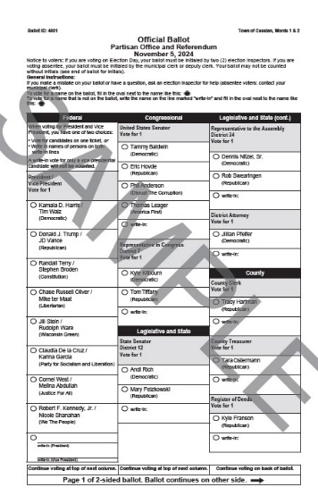

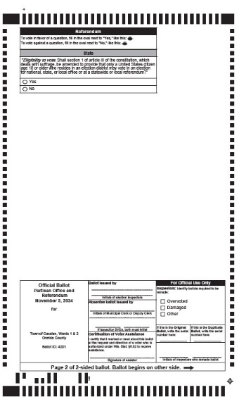

**Federal**

**President / Vice President**

**Vote for 1**

**Democratic**

Kamala D. Harris / Tim Walz

**Republican**

Donald J. Trump / JD Vance

**Constitution**

Randall Terry / Stephen Broden

**Libertarian**

Chase Russell Oliver/Mike ter Maat

**Wisconsin Green**

Jill Stein / Rudolph Ware

**Party for Socialism and Liberation**

Claudia De la Cruz / Karina Garcia

**Justice For All**

Cornel West / Melina Abdullah

**We The People**

Robert F. Kennedy Jr. / Nicole Shanahan

**Congressional**

**United States Senator**

**Vote for 1**

**Democratic**

Tammy Baldwin

**Republican**

Eric Hovde

**Disrupt the Corruption**

Phil Anderson

**America First**

Thomas Leager

**Representative in Congress**

**District 7**

**Vote for 1**

**Democratic**

Kyle Kilbourn

**Republican**

Tom Tiffany

**Legislative and State**

**State Senator**

**District 12**

**Vote for 1**

**Democratic**

Andi Rich

**Republican**

Mary Felzkowski

**Representative to the Assembly**

**District 34**

**Vote for 1**

**Democratic**

Dennis Nitzel, Sr.

**Republican**

Rob Swearingen

**Representative to the Assembly**

**District 35**

**Vote for 1**

**Democratic**

Elizabeth McCrank

**Republican**

Calvin Callahan

**District Attorney**

**Vote for 1**

**Democratic**

Jillian Pfeifer

**County**

**County Clerk**

**Vote for 1**

**Republican**

Tracy Hartman

**County Treasurer**

**Vote for 1**

**Republican**

Tara Ostermann

**Register of Deeds**

**Vote for 1**

**Republican**

Kyle Franson

**Referenda**

**State**

**QUESTION: “*Eligibility to vote.*** *Shall section 1 of article III of the constitution, which deals with suffrage, be amended to provide that only a United States citizen age 18 or older who resides in an election district may vote in an election for national, state, or local office or at a statewide or local referendum?”*

*Yes*

*No*

School District

Prentice

Question: Shall the School District of Prentice, Price, Oneida and Lincoln Counties, Wisconsin be authorized to exceed the revenue limit specified in Section 121.91, Wisconsin Statutes, by $1,200,000 per year for four years, beginning with the 2024-2025 school year and ending with the 2027-2028 school year, for non-recurring purposes consisting of operational and maintenance expenses, including student programming, facility maintenance and staff salaries and benefits?

*Yes*

*N0*

**Notice of Location and Hours of Polling Place**

At the General Election to be held on November 5, 2024, in Oneida County, the following polling place locations will be used for the wards indicated:

|  |  |  |
| --- | --- | --- |
| Municipality | Location | Wards |
| Woodboro | Town Hall - 8672 Old Hwy. K | Ward 1 |

**All polling places will open at 7:00 A.M. and will close at 8:00 P.M. All polling places are accessible to elderly and voters with disabilities*.**

If you have any questions concerning your polling place, contact the municipal clerk.

|  |
| --- |
| Judith A. May – Woodboro Clerk  8672 Old Hwy K Rd. Harshaw, WI 54529  715-282-5607 or 715-490-0146 |

**Notice of Meeting of the Local Board of Canvassers**

At the close of voting on Election Day, pursuant to the provisions of Wis. Stat. § 19.84, the Election Inspectors at each polling place will convene as the Local Canvassing Board for the purpose of conducting the local canvass pursuant to Wis. Stat. § 7.51. This meeting will be open to the public pursuant to Wis. Stat. §§ 19.81-89.

**Notice of Meeting of the Local and Municipal Board of Canvassers (MBOC)**

At the close of voting on Election Day, pursuant to the provisions of Wis. Stat. § 19.84, the Election Inspectors will convene as a joint meeting of the Local Board of Canvassers and the MBOC for the purpose of conducting the local and municipal canvasses pursuant to Wis. Stat. §§7.51 and 7.53(1). This meeting will be open to the public pursuant to Wis. Stat. §§ 19.81-89.